**ST. LUKE’S METHODIST CHURCH**

**25th Sunday after Pentecost and Veterans Sunday**

**November 10th, 2024 ______________ __ ________ 8:30 am**

**✞** *If able, we stand to praise the Lord*

**PRELUDE**

**WELCOME & ANNOUNCEMENTS**

**✞ CALL TO WORSHIP** *Psalm 67:1-2*

May God be gracious to us and bless us

and make his face shine on us—

**so that your ways may be known on earth,**

**your salvation among all nations.**

**✞ OPENING HYMN** “Take Time to Be Holy” Hymnal #395

**✞ OPENING PRAYER**

**O Lord our God, awaken us this hour**

**to the glory of your presence in our midst.**

**Shine among us in such a way**

**that the darkness without and within may be pushed back,**

**such that we might truly see what is real and true.**

**Help us to recognize our sin for what it is.**

**Enable us to behold the world as you created it to be, as you created us to be.**

**Move us from darkness to light, from sin to new life.**

**May your light within us shine through into worship this day, as all days.**

**This we pray in the name of the Word made flesh,**

**the light which is the light of all people, Jesus Christ. Amen.**

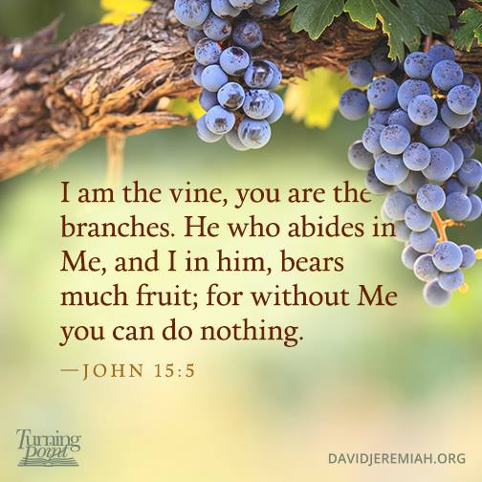

**✞ SCRIPTURE READING**

*John 15:5-8*

Liturgist:

This is the word of the Lord.

**People: Thanks be to God.**

**PRAYER**

**THE LORD’S PRAYER**

**OFFERTORY**

**✞ DOXOLOGY**  “Praise God, from Whom All Blessings Flow” Hymnal #95

**SCRIPTURE LESSON**  *Hebrews 7:14-25*

**MESSAGE**  Pastor Dan Gedman

**RECOGNITION OF VETERANS**

**✞ HYMN** “Be Thou My Vision” Hymnal #451

**✞ BENEDICTION**

**POSTLUDE**

The flowers on the altar

are to honor and glorify Almighty God

and in thanksgiving and gratitude

for our St. Luke’s Veterans

and their service to our country.

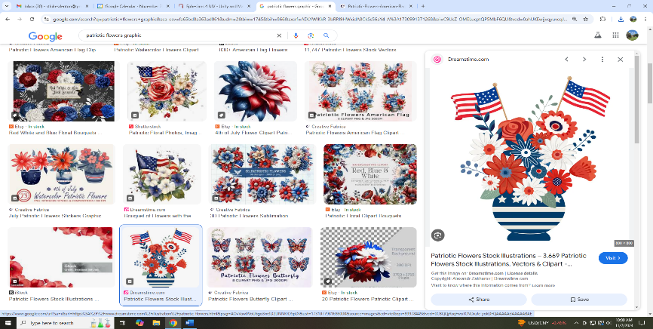

**Assisting in Worship**: Carrie Soldano/Mitchell Griffith/Joan Wolff (on piano)

**Prayer Concerns**:

*For those in our parish & community needing healing and comfort*:

Jason Tuel, David Lankford, Betty Barwick, Alicia Weippert, Myles Adams, Cristy Russell, Cindy Nicklin, Bette Shull, Abby, Eddie Anderson, Craig Little, Kolby Downes, Sylvia Holland, Keilani Maloney, Carol Foster, Renee Barringer, Samantha McCall, Bruce Hastings, Patsy Biggers, Michael Mumford, Patty Downes, Jason Lee, and Mary Lynn Meloni.

*Pray for* the Holy Spirit to bring peace and unity in our church and in churches across the world; for the lost to be found and for our hearts to see the lost; for our leaders in the GMC and at St. Luke’s to lead us to “worship passionately, love extravagantly, and witness boldly.”

**In sympathy to the family and friends of** Howard Hodges, James A. Gibbs, and Ruth Moore

**For those serving in the U.S. Military:** Chelsea Bunker, Seth Gill, Gabe Griffith, Ethan Lister, Teagan Lister, Matthew Parker, Andrew Robbins, and Jack Schroeder.

**This Week at St. Luke’s _____ _ ____ ______ _ Nov. 10th - Nov. 17th**

Sunday:  8:30 am & 10:00 am Worship Services

9:30 am – Adult Sunday School – Room 1

9:45 am – Sunday School – Chapel

Monday: 10:00 am & 7:00 pm – Daniel Bible Study – Room 1

Tuesday: 10:00 am – Prayer Team – Room 1

7:30 pm – Praise Band Practice – Fellowship Hall

Saturday: 9:00 am – NE Conference District Meeting – FH

Sunday:8:30 am & 10:00 am Worship Services

9:30 am – Adult Sunday School – Room 1

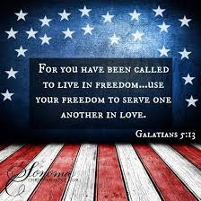9:45 am – Sunday School – Chapel

**Attendance & Stewardship**

8:30 am – 49 10:00 am - 47

Sunday School Children: 36 Adults: 11

Needed Weekly: $4,300.00

Giving Last Week: $6,423.00





**St. Luke’s Methodist Church**

***A Global Methodist Church***

100 S. 5th Avenue, Denton, Maryland 21629

**The Reverend Daniel Gedman, Pastor**

Garrett Shull, Director of Youth Ministries

Carrie Soldano, Administrative Assistant

Alicia Weippert, Director of Ignite Praise Band

Alex Penn, Nursery Coordinator

**Church Office: 410-479-2171**

**Pastor Dan: 443-693-3694**

**Email:** [***stlukesdenton@gmail.com***](mailto:stlukesdenton@gmail.com)

**Website: *www.stlukesdenton.org***